State Office Personnel - PO Box 158 Troutville, VA Phone: 540-992-3696

Executive Secretary, Judy Schall | Email: Judys0830@sbcglobal.net  Cell: 864-933-1899
Finance Director, Gail Hubble | Email: financedirector@vacogop.org | 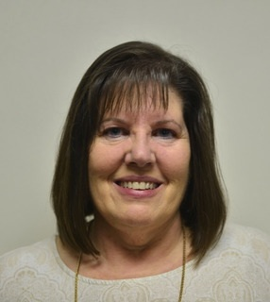

Specialized Ministry Directors

State Children’s Director | Melinda Kay | melinda.kay@maag.com  540-863-8466 (Home)  540-691-6584 (Cell)  611 Park Street  Clifton Forge, VA 24422 | 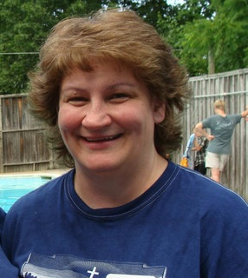
State Camp Coordinators | Ray & Nikki Burton | nburton4Him@gmail.com (Nikki)  trburton4him@gmail.com (Ray)  540-958-3128 (Nikki)  540-958-4499 (Ray)  2457 Magnolia Ave.,  Buena Vista, VA 24416 | 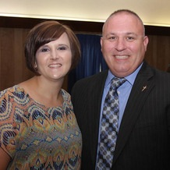
Ladies’ Ministries | Phyllis Cooper | psidescooper@gmail.com  169 Sunset Circle  Madison Heights, Virginia 24572  Phone: 434-426-5304 | 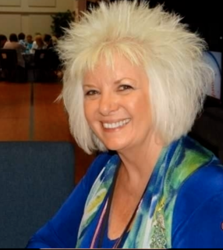
Couples’ & Music Ministries | Chad & Ashley Lambert | chad@allnationschurch.org  853 Cloverleaf  Newport News, VA 23601  Phone: 757-941-5111 | 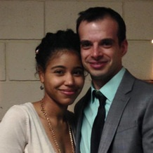
Leadership Development | Milton Atkins | matkins@harvest-ministries.org  284 Brookfield Lane  Roanoke, VA 24012  Home: 540-977-4771
Ladies’ Retreat Gatlinburg | Peggy Brown | 116 Harvest Lane  Daleville, VA 24083  Phone: 540-992-5394 | 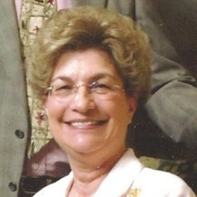
State Photographer | Ben Fulton | bmfoto1@aol.com  PO Box 4164  Suffolk, VA 23439-4164  Cell: 757-676-3394 | 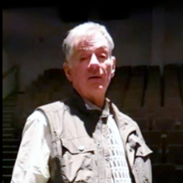
State Office Legal Consultant | L. Keith Lambert | lkeithlambert@aol.com  1001 Lyons Head  Virginia Beach, VA 23452-6163  Phone: 757-463-7665
State Properties
Camp Caretaker & Kitchen Manager | Justin & Angel Vaughan | Home: 540-297-5205  Cell: 276-237-7855(Justin)  Cell: 276- 233- 9846 (Angel)  buildinghouses2008@yahoo.com (Justin)  amhodge@vt.edu (Angel) | 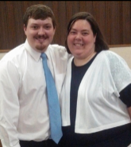

Summer Camp Directors
Ray & Nikki Burton | Teen  (Ages 13-19) | nburton4Him@gmail.com (Nikki)  trburton4him@gmail.com (Ray)  540-958-3128 (Nikki)  540-958-4499 (Ray)  2457 Magnolia Ave.,  Buena Vista, VA 24416
Melinda Kay | Voyager  (Ages 9-12) | melinda.kay@maag.com  540-863-8466 (Home)  540-691-6584 (Cell)  611 Park Street  Clifton Forge, VA 24422
J. D. & Mary Chapman | Hot Shot  (Ages 5-8) | chapjane@aol.com (Mary)  chapmjd@ail.com (JD)  133 Greenwood Dr.,  Madison Heights, Va. 24572  Mary (cell) 434-610-2126  JD (cell) 434-610-6115 | 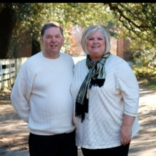

Note: All State Staff may be reached through the State Office: 540-992-3696

Visit our State Website for more information: http://www.vacogop.org

